**KWAME NKRUMAH UNIVERSITY OF SCIENCE AND TECHNOLOGY, KUMASI**

**COLLEGE OF ENGINEERING**

**BSc. AEROSPACE ENGINEERING**

**ME 392- INDUSTRIAL ENGINEERING AND ERGONOMICS**

**ASSIGNMENT BY**

**ARTHUR EMMANUEL**

**INDEX NUMBER: 9804013**

**RESEARCH ON THE VARIOUS CHARTS USED IN METHOD STUDYB IN METHOD ENGINEERING.**

**25TH FEBRUARY, 2016**

# FLOW PROCESS CHART

They are graphic representations of operations, transportation, inspections, delays and storages occurring during a process or a procedure and include information considered for analysis such as, time required and distance moved.

* **When is it used?**
* It is used when observing a physical process, to record actions as they happen and thus get an accurate description of the process.
* It is used when analyzing the steps in a process, to help identify and eliminate waste- thus, it is a phenomenal tool when it comes to efficiency planning.
* It is used when the process is mostly sequential, containing few decisions.
* **What is on it?**

|  |  |  |
| --- | --- | --- |
| SYMBOL | LETTER | DESCRIPTION |
| O | O | Operation |
|  | I | Inspection |
| ⟶ | M | Move |
| D | D | Delay |
| ∇ | S | Storage |

* Operation: to change the physical or chemical characteristics of the material.
* Inspection: to check the quality or the quantity of the material.
* Move: transporting the material from one place to another.
* Delay: when material cannot go to the next activity.
* Storage: when the material is kept in a safe location.

**EXAMPLE OF A FLOW PROCESS CHART.**

|  |  |  |  |  |  |  |  |  |  |  |  |  |  |
| --- | --- | --- | --- | --- | --- | --- | --- | --- | --- | --- | --- | --- | --- |
| Title: Cases of safety boots | | Charted by: Arthur Emmanuel | | | | | | | | | | | |
| Activity: Receiving and store in storehouse | | Supervised by: Jay Mokoadjoa | | | | | | | | | | | |
| Department: Storage department | | Date: 23rd February, 2016 | | | | | | | | | | | |
| Method: Proposed | | Chart no.: 001 | | | | | | Sheet no. 1 of 1 | | | | | |
| Description | Distance (m) | | Time (min) | Symbol | | | | | | | | | Remarks |
| O |  | | ⟶ | | | D | ∇ | |
| Convey cases to storehouse | 9 | | 3 |  |  | * | | |  | | |  | 1 laborer |
| Wait to be unloaded |  | | 1 |  |  |  | | | * | | |  |  |
| Cases inspected and numbered |  | | 1 |  | * |  | | |  | | |  | 2 laborers |
| Cases stored |  | |  |  |  |  | | |  | | | * |  |

# FLOW DIAGRAM

It is a flow process chart drawn to show the layout of a facility. It gives pictorial view of the layout of workplace on which locations of different equipment, machines etc. are indicated.

* **When is it used?**
* It is used to look for spatial relationships.
* **What is on it?**
* It shows de spatial arrangements of machines and materials in the workplace.
* The movement of the subject is indicated on the diagram by a line.

**EXAMPLE OF A FLOW DIAGRAM.**

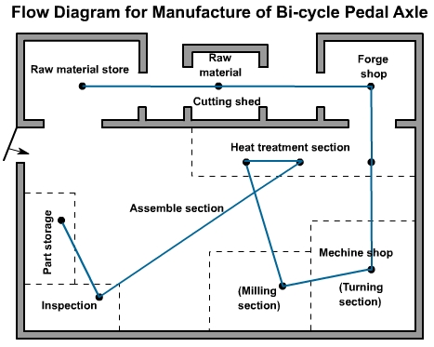

# TRAVEL CHART

A travel chart is a tabular record for pressing quantitative data about the movements of subject between any numbers of places over a given period of time

* **When is it used?**
* It is used when there are multiple (possibly irregular) movement between places.
* **What is on it?**
* A square table and each square within table represents a station.
* It has number of rows and columns equal to the number of stations that can be visited by the subject.

**EXAMPLE OF A TRAVEL CHART.**

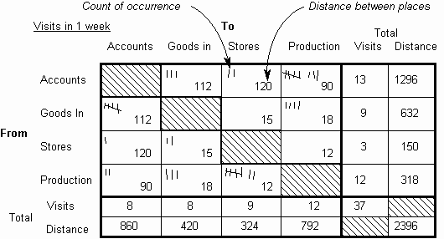

# GANG PROCESS CHART

It is a chart which illustrates a job in which a team of workers are interating with a piece of equipment or a machine.

* **When is it used?**
* Used when the number of workers needed per machine to accomplish a particular is to be known.
* Also used when the interaction between workers and machines is to be known for maximum efficiency.

**EXAMPLE OF A GANG PROCESS CHART.**

|  |  |  |  |  |  |
| --- | --- | --- | --- | --- | --- |
| PERSON | | | | MACHINE | |
| Customer | Time (s) | Clerk | Time (s) | Coffee Grinder | Time (s) | |
| Ask grocer for 1 pound of coffee | 5 | Listen to order | 5 | Idle | 5 | |
| Wait | 15 | Get coffee and put in machine, set grind and start grinder | 15 | Idle | 15 | |
| Wait | 21 | Idle while machine grinds | 21 | Grind coffee | 21 | |
| Wait | 12 | Stop grinder, place coffee in package, and close it | 12 | Idle | 12 | |
| Receive coffee from grocer, pay grocer, and receive change | 17 | Give coffee to customer, wait for customer to pay for coffee, receive money and make change | 17 | Idle | 17 | |

# OPERATOR PROCESS CHART

It is a chart of the time relationship of the movements made by the body members of a workman performing an operation. In this chart the activities of a worker’s hands (or limbs) are recorded in their relationship to one another***.***

* **What is it used for?**
* Useful in analyzing the work performed by one person at one specific workstation by analysing the motions used by the worker in performing the activity.
* to eliminate or reduce the unwanted motions and to arrange the remaining motions
* **What is on it?**
* Each hand of the worker is treated as an activity.
* Each hand’s activities are broken into work elements and plotted side by side on a time scale.

|  |  |  |
| --- | --- | --- |
| SYMBOL | DESCRIPTION | MEANING |
| O | Operation | An operation occurs when the hand grasps, releases or assembles tool, material, component etc. |
|  | Inspection | It is done to check the quality or the quantity of the material. |
| ⟶ | Transport | Transport occurs when the hand moves from one position to another at the work place. |
| D | Delay | Delay occurs when the hand is Idle in the sense that it is not performing any activity |
| ∇ | Hold | A hold occurs when the hand holds an object so that the other hand may be able to do something to that object |

**EXAMPLE OF AN OPERATOR PROCESS CHART.**

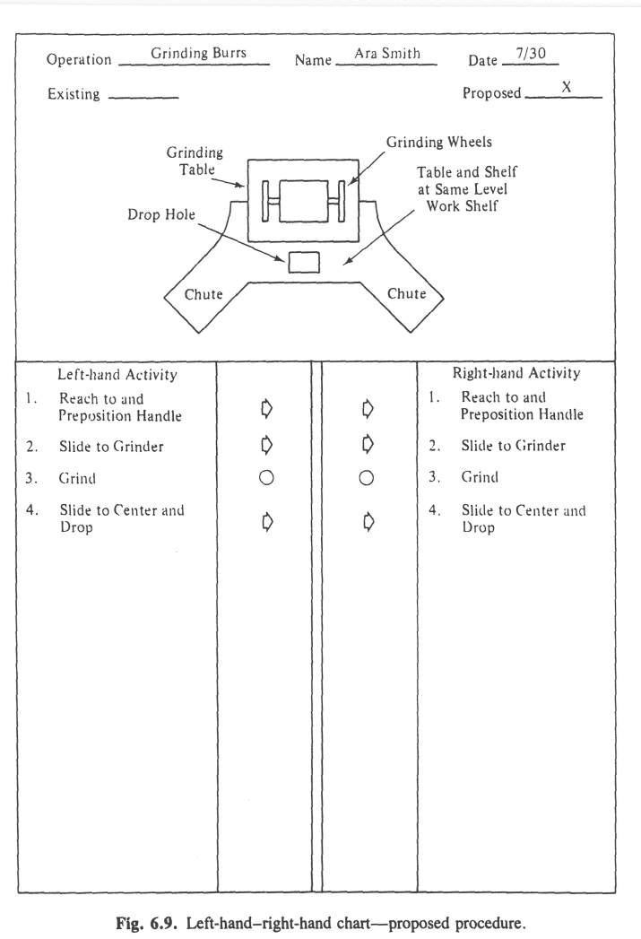

# MAN-MACHINE CHART

Multiple Activtiy Chart is a chart in which the activities of more than one item are recorded on a common time scale to show their inter-relationship. Man machine chart is the type of multiple activity charts.

The worker and machine process chart (Man-machine chart) is used to study, analyze, and improve one workstation at a time.

The chart shows the exact time relationship between the working cycle of the person and operating cycle of the machine.

These facts can lead to utilization of both worker and machine time, and a better balance of the work cycle.

**Example of Man-Machine Chart**

|  |  |  |  |
| --- | --- | --- | --- |
| **TIME (MIN)** | **MAN** | **MACHINE** | **TIME (MIN)** |
| 0.2 | Remove finished casting cleans with compressed air | IDLE | 0.2 |
| 0.4 | Gauge depth of slot on surface plate | IDLE | 0.4 |
| 0.8 | PLACE in a box obtains new casting | IDLE | 0.8 |
| 1.0 | Cleans machine with compressed air | IDLE | 1.0 |
| 1.2 | Locates castings in fixture, starts machine | IDLE | 1.2 |
| 1.4 | IDLE | Cutting slot 1 | 1.4 |
| 1.6 | IDLE | Cutting slot 2 | 1.6 |
| 1.8 | IDLE | Cutting slot 3 | 1.8 |
| 2.0 | IDLE | Cutting slot 4 | 2.0 |

Cycle time (min) = 2.0

|  |  |  |  |
| --- | --- | --- | --- |
| **Man – Machine** | **Working Time (min.)** | **Idle Time (min.)** | **Utilization**  **(%)** |
| MAN | 1.2 | 0.8 | 60% |
| MACHINE | 0.8 | 1.2 | 40% |

**Improved Method**

|  |  |  |  |
| --- | --- | --- | --- |
| **TIME (MIN)** | **MAN** | **MACHINE** | **TIME (MIN)** |
| 0.2 | REMOVED FINISHED CASTING CLEANS WITH COM PRESED AIR | IDLE | 0.2 |
| 0.4 | CLEAN MACHINE WITH COMPRESED AIR | IDLE | 0.4 |
| 0.6 | LOCATEES A NEW CASTING IN A FIXTURE START MACHINE | IDLE | 0.6 |
| 0.8 | BREAKS SHARP EDGES WITH FILES CLEANS WITH COMPRESSED AIR | CUTTING SLOT 1 | 0.8 |
| 1.0 | GAUGE DEPTH OF SLOT ON SURFACE PLATE | CUTTING SLOT 2 | 1.0 |
| 1.2 | PLACES CASTING IN A BOX PICKS UP NEW CASTING AND PLATE BY MACHINE | CUTTING SLOT 3 | 1.2 |
| 1.4 | IDLE | CUTTING SLOT 4 | 1.4 |

Cycle Time(min) = 1.4

|  |  |  |  |
| --- | --- | --- | --- |
| **Man – Machine** | **Working Time (min.)** | **Idle Time (min.)** | **Utilization**  **(%)** |
| MAN | 1.2 | 0.2 | 85.7% |
| MACHINE | 0.8 | 0.6 | 57.0% |

**Comparison between Present and Improved Method**

|  |  |  |  |
| --- | --- | --- | --- |
|  | **CYCLE TIME (MIN)** | **MAN IDLE TIME(MIN)** | **MACHINE IDLE TIME ( MIN)** |
| **PRESENT METHOD** | **2.0** | **0.8** | **1.2** |
| **IMPROVED METHOD** | **1.4** | **0.2** |  |

# ACTIVITY CHART

Multiple activity charts are the process charts using a time scale. It usually comes in picture when work study man wants to record the activities of one subject with respect to other on a single chart. Subject may be the worker, machine or equipment.

**Construction of Chart**

First of all, separate bars or columns are allotted to each subject. These subjects are placed against a common time scale. Activities of worker and machine are recorded by shading the respective bars or columns. Time studies conducted previously provide the time values for each activity. Now, the activities are plotted in sequence against the common time scale. A man-machine activity chart explaining the process of reading a deck of cards in card reader is drawn below.

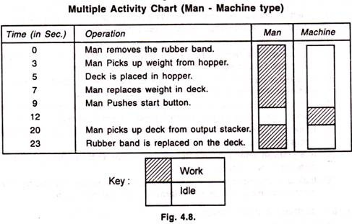

# SIMO CHART

Simultaneous-Motion cycle : It is a graphic representation of an activity and shows the sequence of the therbligs or group of therbligs performed by body members of operator. It is drawn on a common time scale. In other words, it is a two-hand process chart drawn in terms of therbligs and with a time scale,

It is generally not possible to time individual therbligs. A certain number of therbligs may be grouped into an element large enough to be measured as can be seen in Figure.

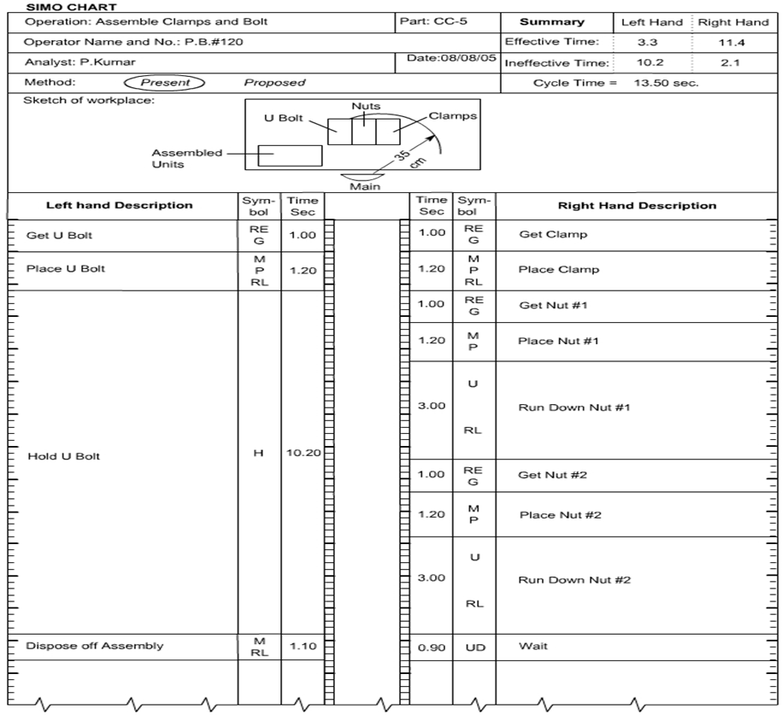

**Uses of Simo Chart**

From the analysis shown about the motions of the two hands (or other body members) involved in doing an operation, inefficient motion pattern can be identified and any violation of the principle of motion economy can be easily noticed. The chart, therefore, helps in improving the method of doing an operation so that balanced two-handed actions with coordinated foot and eye motions can be achieved and ineffective motions can be either reduced or eliminated. The result is a smoother, more rhythmic work cycle that keeps both delays and operator fatigue to the minimum extent.

# OPERATION PROCESS CHART.

It is a graphical and symbolic representation of the manufacturing operations used to produce a product.

* **What is its use?**
* to illustrate only the value-adding activities in the manufacturing process.

It involves

1. Processing and assembly operations: [Processing](https://en.wikipedia.org/wiki/Process_(engineering)) operation such as changing in shape and properties. On the other hand, joining two or more parts is an [assembly](https://en.wikipedia.org/wiki/Manufacturing) operation. Furthermore, these two operations are represented by this symbols, circle (○) and (O) letter.
2. Inspection operations: [Inspection](https://en.wikipedia.org/wiki/Inspection) operations are represented by square symbol (□) and (I) as letter. It's done by an inspector checks the material, work part and assembly for quality and quantity.

It also shows materials used and the time taken by operator for different elements of work.

# References

* Production management
* Operations management
* en.wikipedia.org